EX6: Create a simple cloud software application for Payroll Processing System using any Cloud Service Provider to demonstrate SaaS include the necessary fields such as Name of the employee, experience in present org, over all experience, basic pay, HRA, DA, TA, net pay, gross pay etc.

PROCEDURE:

Step 1: Create a new application name such as the payeasy

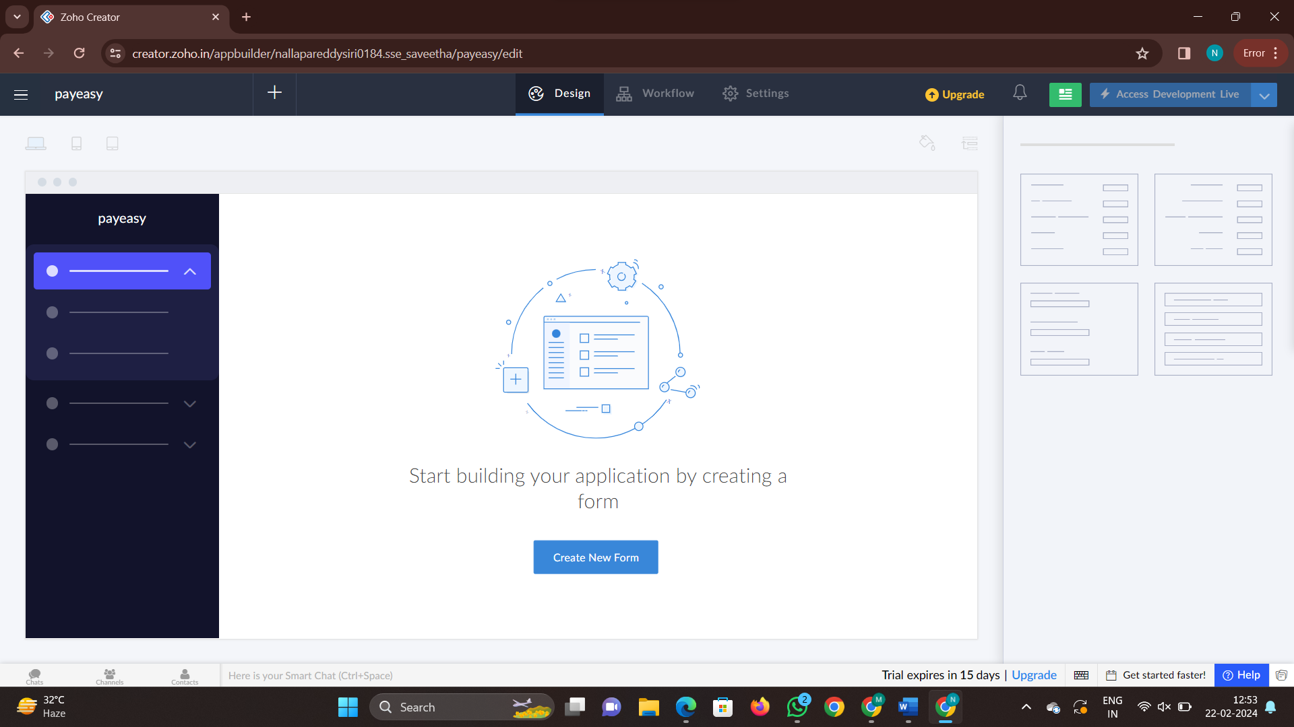

Step2: Now create a form to enter the details

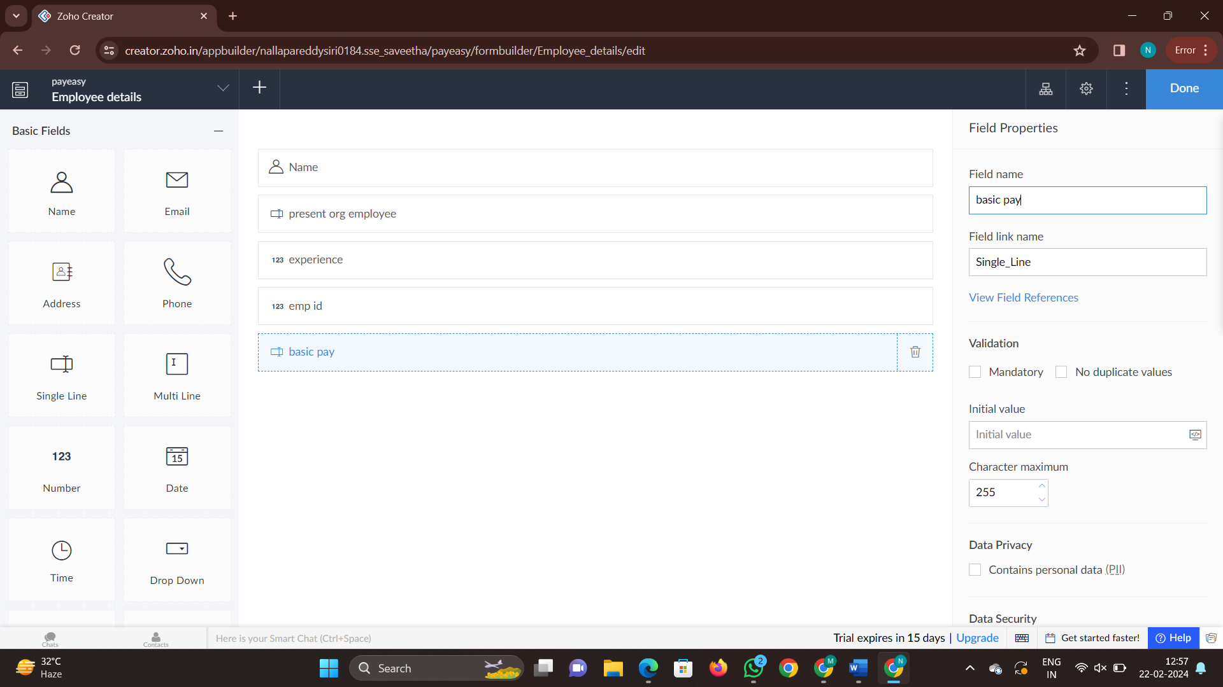

Step 3: Now click on done to create another form

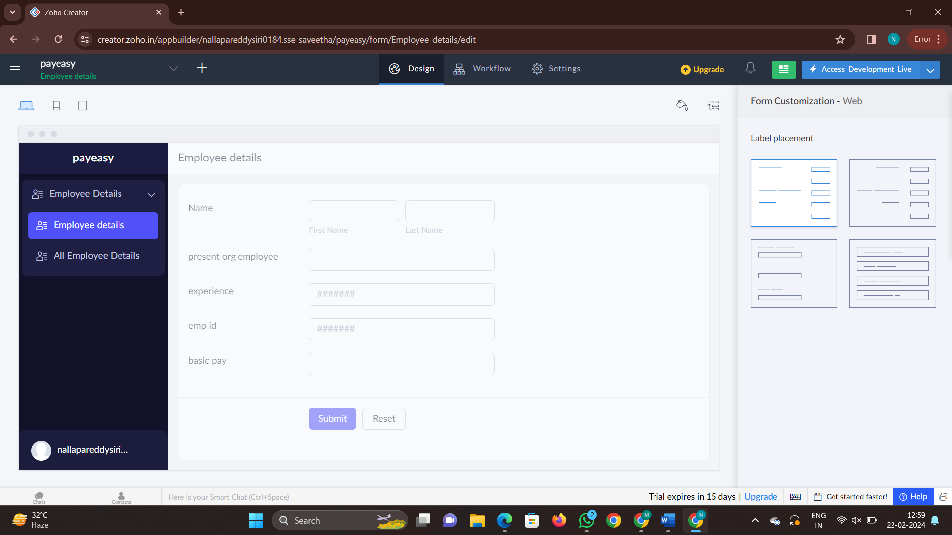

Step 4: now click on access development live to access the application

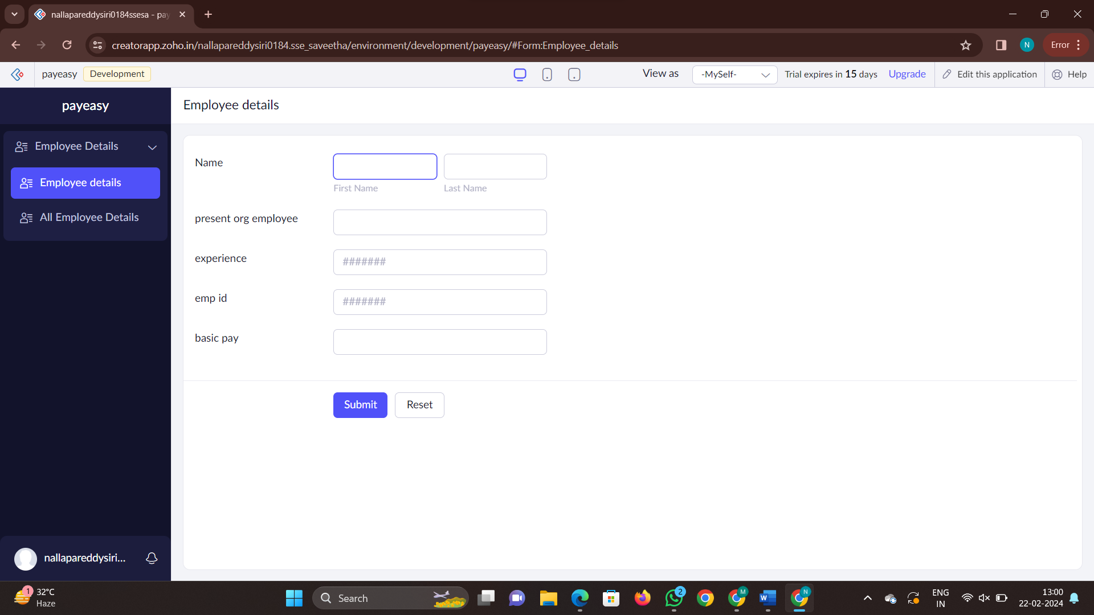

Step 5: now fill the details and check report which is created automatically

